**Tutorial 1 (Finding interact partners (ACR11) with Fd-GOGAT(Glu1))**

To show a migration profile of Glu1, you can search it by GeneID (At5g04140), Symbol (Glu1), and Description (Glutamine synthase).

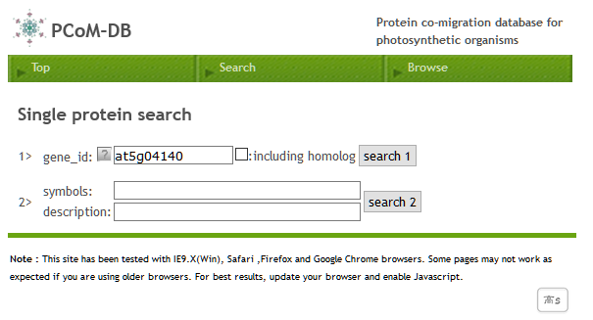

The resulting page shows heat maps of Glu1 migration profiles across Arabidopsis samples. Each column represents a gel slice of a BN-PAGE gel and gel slices are ordered left (a top of gel) to right (a bottom of gel). In case a column is red-colored, a searching protein was identified by LC-MS/MS extracted from the corresponding gel slice of the BN-PAGE gel. The depth of the red-color reflects the relative abundance of the protein accumulation level, which was estimated by a label-free semi-quantitative method, emPAI (Exponentially Modified Protein Abundance Index).

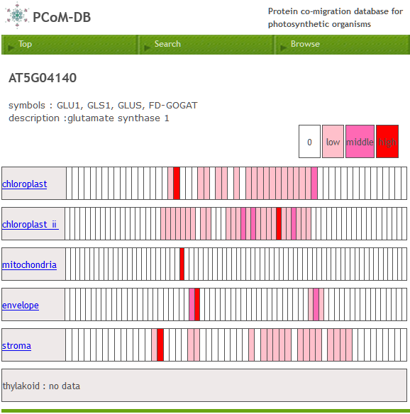

If your protein of interest is Arabidopsis protein and has homologous proteins in “non-Arabidopsis organisms”, the migration profiles of the homologous proteins in non-Arabidopsis organisms will also be appeared.

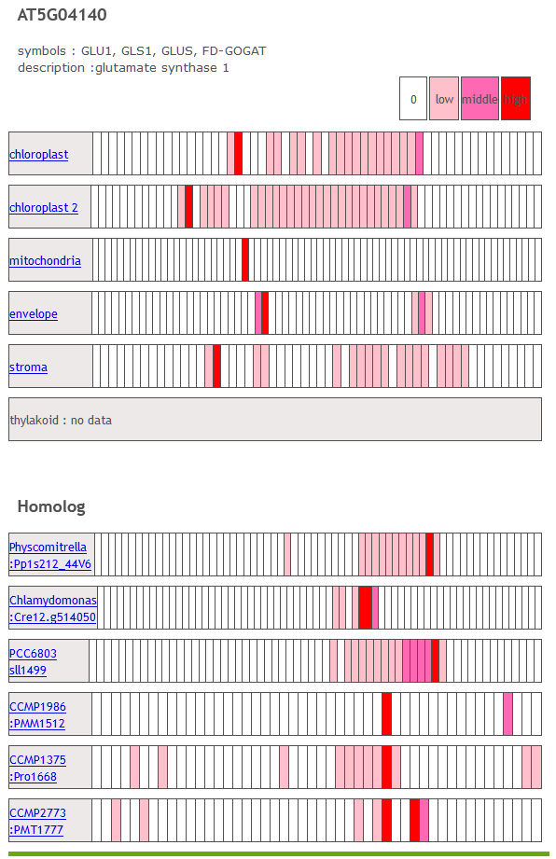

Then, you can select the sample. After you click the sample name (chloroplast), the Glu1 migration profile will be appeared. A closed circle represents the emPAI value of your searching protein in each corresponding gel slice. You can move the mouse cursor over any data point and can see the emPAI value (2.41 for Glu1 in gel slice 19) in the corresponding gel slice.

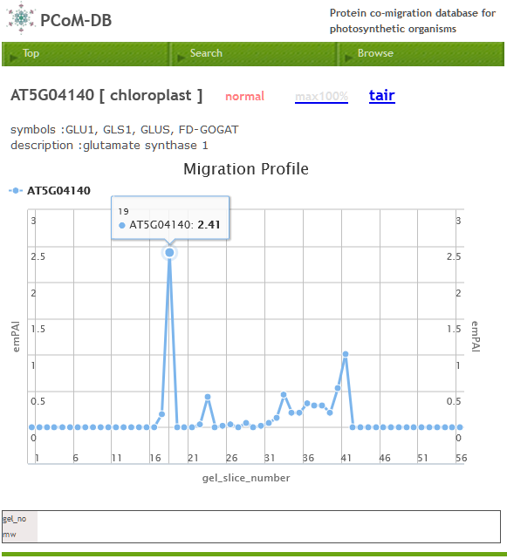

Also, you can click any data point and see the list of the proteins which were identified by LC-MS/MS in the corresponding gel slice. In this example, ACR11 (At5g04140) is included in the protein list. You can compare migration profiles of proteins with your searching protein by clicking the checkboxes followed by clicking a “rechart”. migration profiles of ACR11 and Glu1 (At5g04140) shares the peak in gel slice 19, suggesting that ACR11 and Glu1 forms a protein complex in the corresponding gel slice. You can estimate the sharing peak by indicating “P” in “peak” column.

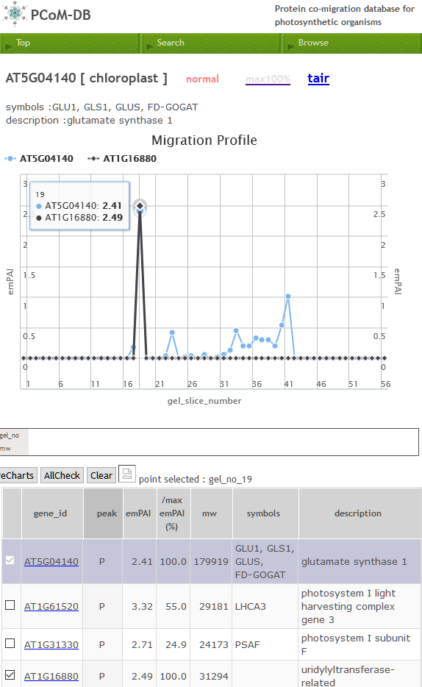

Note that a peak in a protein migration profile should be corresponding a protein band on BN-PAGE. Thus, a shared peak in the migration profiles should indicate that these proteins are co-migrated on BN-PAGE, suggesting that these proteins potentially form a protein complex.